**Vaccination Status**

Mini Project Report submitted to Savitribai Phule Pune University, Pune



In partial Fulfillment for the awards of Degree of Engineering in

Computer Engineering TE(Computer)

**Submitted by**

Mr. Yash Bagul (Roll No :- 06)

Mr. Yuvraj Bargaje (Roll No :- 07)

Mr. Onkar Halasawade (Roll No :- 29)

Mr. Jaydeep Sinde (Roll No :- 67)

**Under the Guidance of**

**Prof. Rupali Wagh**



# Department of Computer Engineering

Parvatibai Genba Moze College Of Engineering, Wagholi, Pune

(2022-23)

# Certificate



This is to certify that, Mr. Yash Bagul (Roll No :- 06) Mr. Yuvraj Bargaje (Roll No :- 07), Mr. Onkar Halasawade (Roll No :- 29), Mr. Jaydeep Shinde (Roll No :- 67) have successfully completed the Mini project entitled “Vaccination Status**’’** under my guidance in partial fulfillment of the requirements for the Third Year of Engineering in Computer Engineering under the Savitribai Phule Pune University during the academic year 2022- 2023

|  |  |
| --- | --- |
| **Prof. Rupali Wagh** | **Prof. Shrikant Dhamdhere** |
| **Project Guide** | **Head Of Department** |

**Date : / /**

**Place :** Pune

# Acknowledgements

With deep sense of gratitude we would like to thank all the people who have lit our path with their kind guidance. We are very grateful to these intellectuals who did their best to help during our project work.

It is our proud privilege to express a deep sense of gratitude to **Prof. Dr. M . G.**

**Jadhav,** Principal of Parvatibai Genba Moze College Of Engineering, Wagholi,

Pune for his comments and kind permission to complete this project. We remain

indebted to **Prof. Shrikant Dhamdhere,** H.O.D. Computer Engineering

Department for his timely suggestion and valuable guidance. The special

gratitude goes to (**Prof. Rupali wagh**) excellent and precious guidance in

completion of this work .We thanks to all the colleagues for their appreciable

help for our working project. With various industry owners or lab technicians to

help, it has been our endeavor throughout our work to cover the entire project

work.

We are also thankful to our parents who provided their wishful support for our project completion successfully .And lastly we thank our all friends and the people who are directly or indirectly related to our project work.

Mr. Yash Bagul (Roll No :- 06)

Mr. Yuvraj Bargaje (Roll No :- 07)

Mr. Onkar Halasawade (Roll No :- 29)

Mr. Jaydeep Shinde (Roll No :- 67)

# Abstract

The COVID-19 vaccines have been developed to help fight the COVID-19 pandemic by teaching the body's immune system how to recognize and fight the virus. The vaccines have undergone rigorous testing in clinical trials to ensure their safety and efficacy, and they have been shown to be highly effective in preventing COVID-19 infections, severe illness, hospitalization, and death. There are several types of COVID-19 vaccines, including mRNA, viral vector, and protein subunit vaccines. Vaccines are available to most age groups in many countries, and priority has been given to those at higher risk of severe COVID-19. While the vaccines are highly effective, it is important to continue following public health measures to prevent the spread of COVID-19.

**Table of Contents**

* **Acknowledgement**
* **Abstract**
* **Introduction**
* **Software Requirements Specifications**
* **Code**
* **Output**
* **Conclusion**
* **References**

# 

**Introduction**

Vaccination status refers to the current state of an individual’s vaccination history. Vaccination is a process of administering vaccines to stimulate an individual’s immune system to develop immunity against a particular disease.

The topic of vaccination status is crucial in today's world, particularly in the context of the ongoing COVID-19 pandemic. Vaccination is one of the most effective ways to prevent the spread of infectious diseases and keep individuals healthy. With the advent of COVID-19 vaccines, it has become essential to understand the significance of vaccination status and its impact on public health. In this college project, we will explore the importance of vaccination status, the various types of vaccines available, the benefits of getting vaccinated, and the potential risks and concerns associated with vaccines. We will also examine the impact of vaccination status on individual health and community well-being. Through this project, we aim to provide a comprehensive understanding of the significance of vaccination status and its role in promoting public health.

The project will involve conducting research on vaccination status, analyzing data related to vaccination rates, and exploring the factors that influence vaccination decisions. Additionally, we will examine the ethical considerations related to mandatory vaccination policies and discuss the role of healthcare providers in promoting vaccine uptake.

Overall, this project aims to provide a comprehensive understanding of vaccination status and its impact on public health. By examining the benefits, risks, and challenges associated with vaccines, we hope to promote informed decision-making and encourage individuals to take an active role in protecting their health and the health of their communities.

**Software Requirements Specification**

**Hardware Requirements**

* Higher Processor of 2.4 GHZ speed
* 8GB RAM maximum
* 80GB maximum disk space

**Software Requirements**

* Operating System (Windows 10 or later)
* Visual Studio

## Codes:

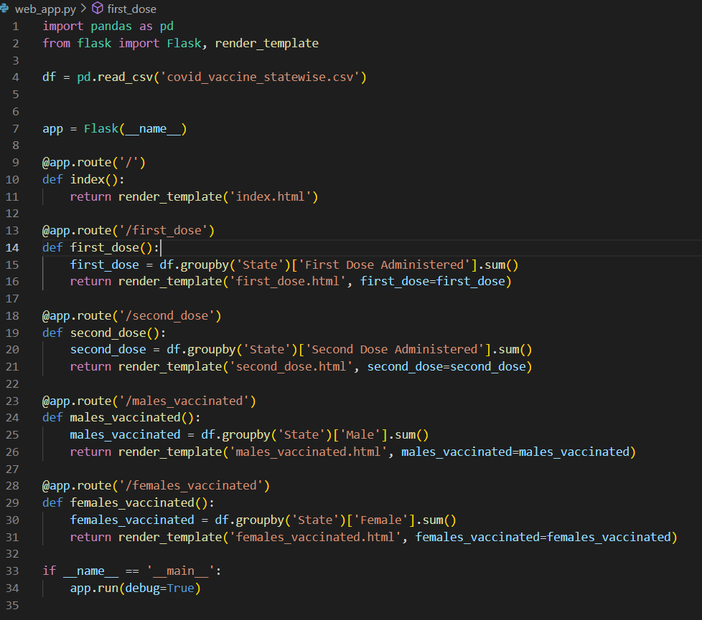

**Output**

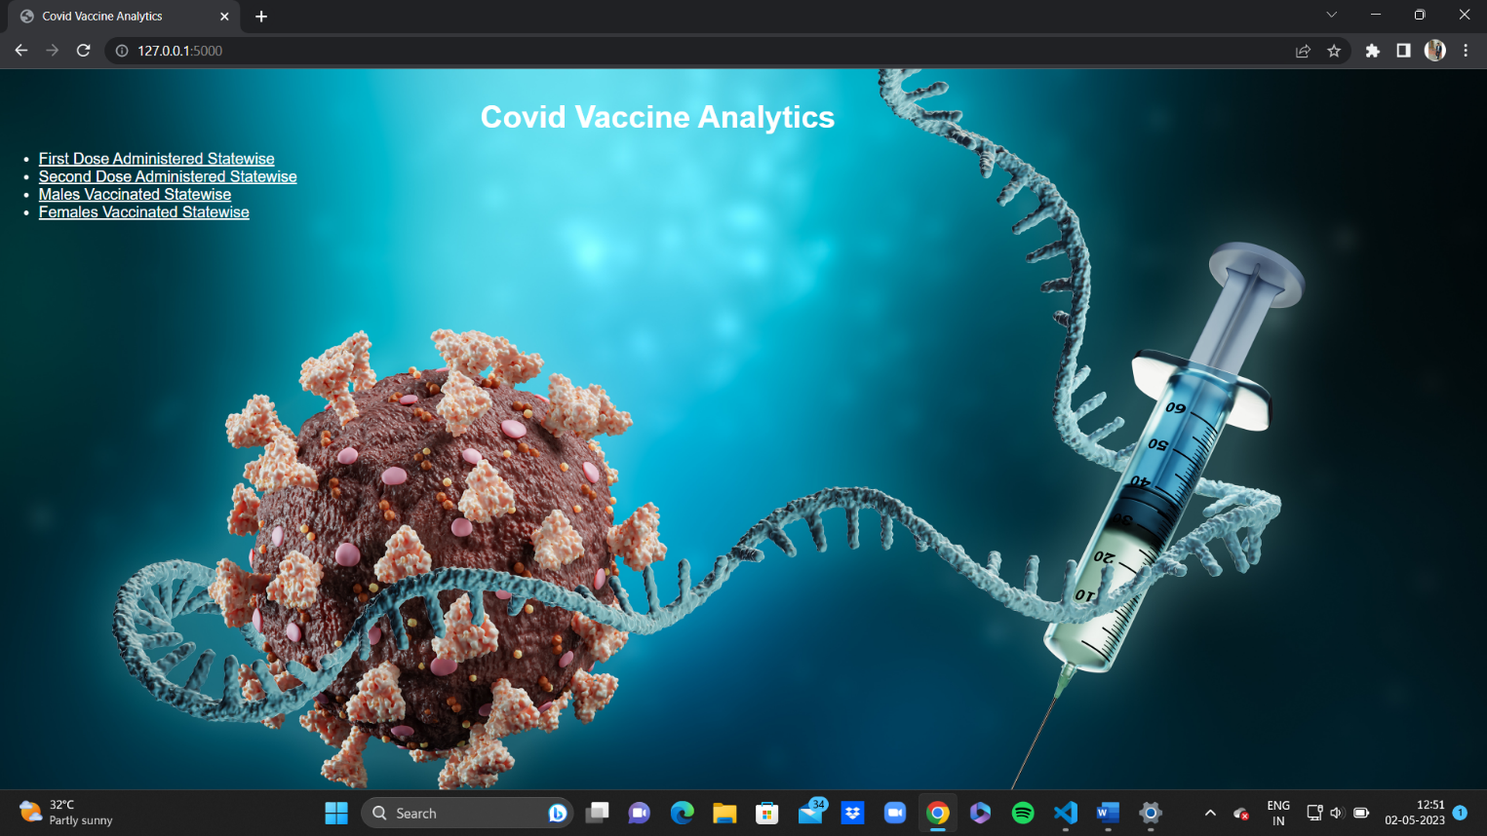

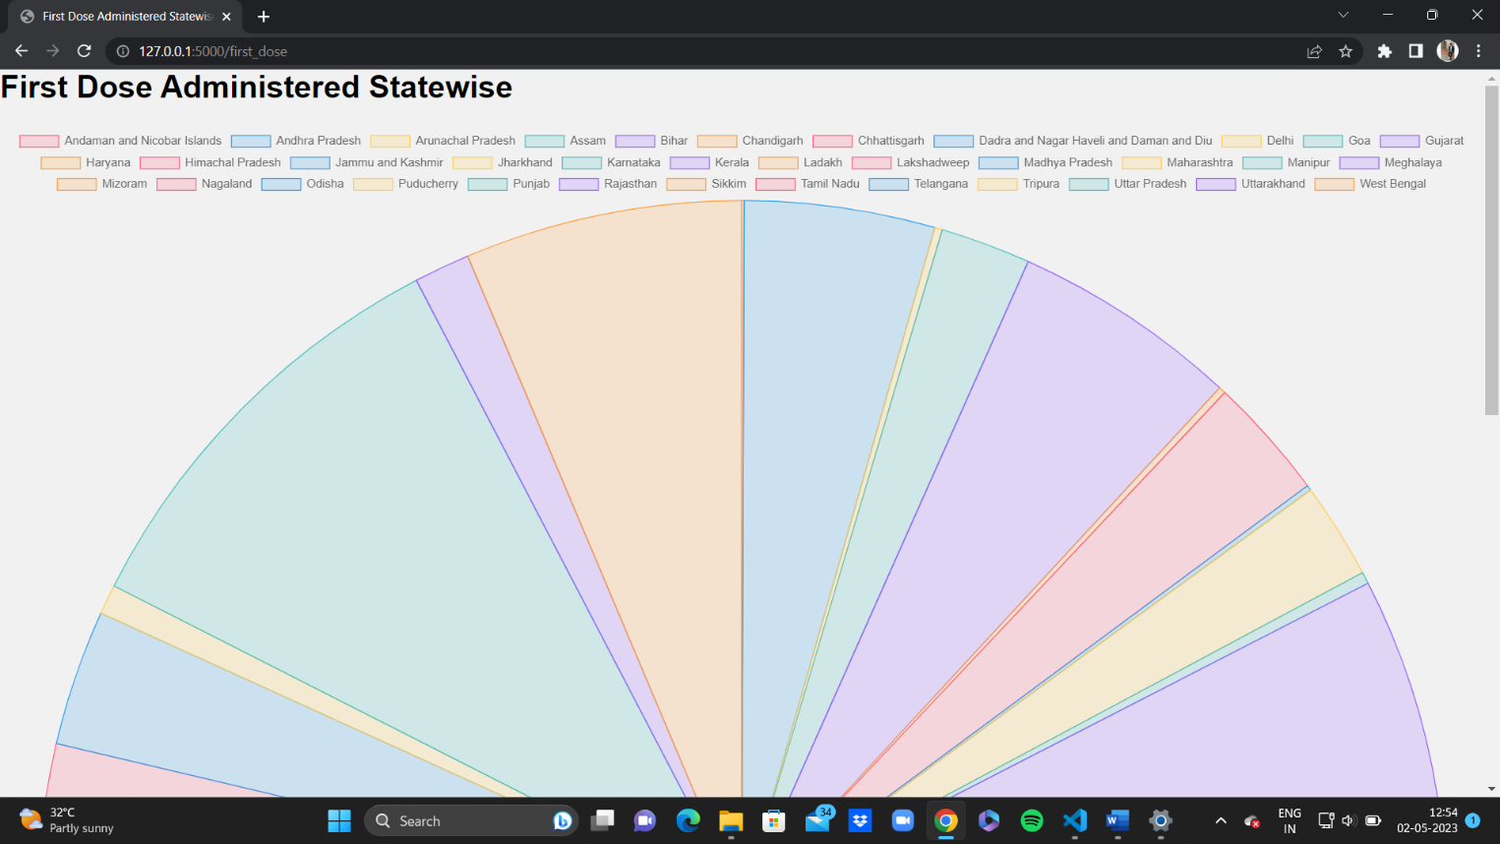

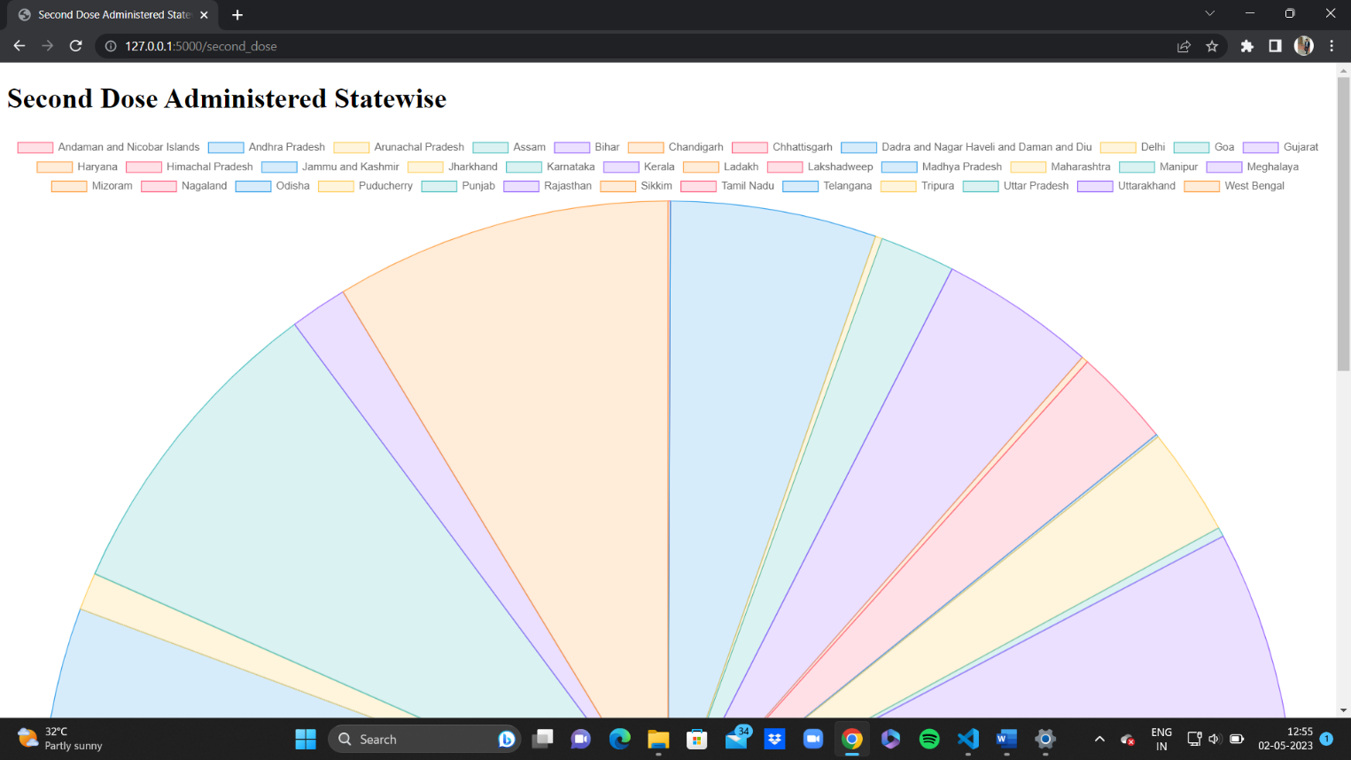

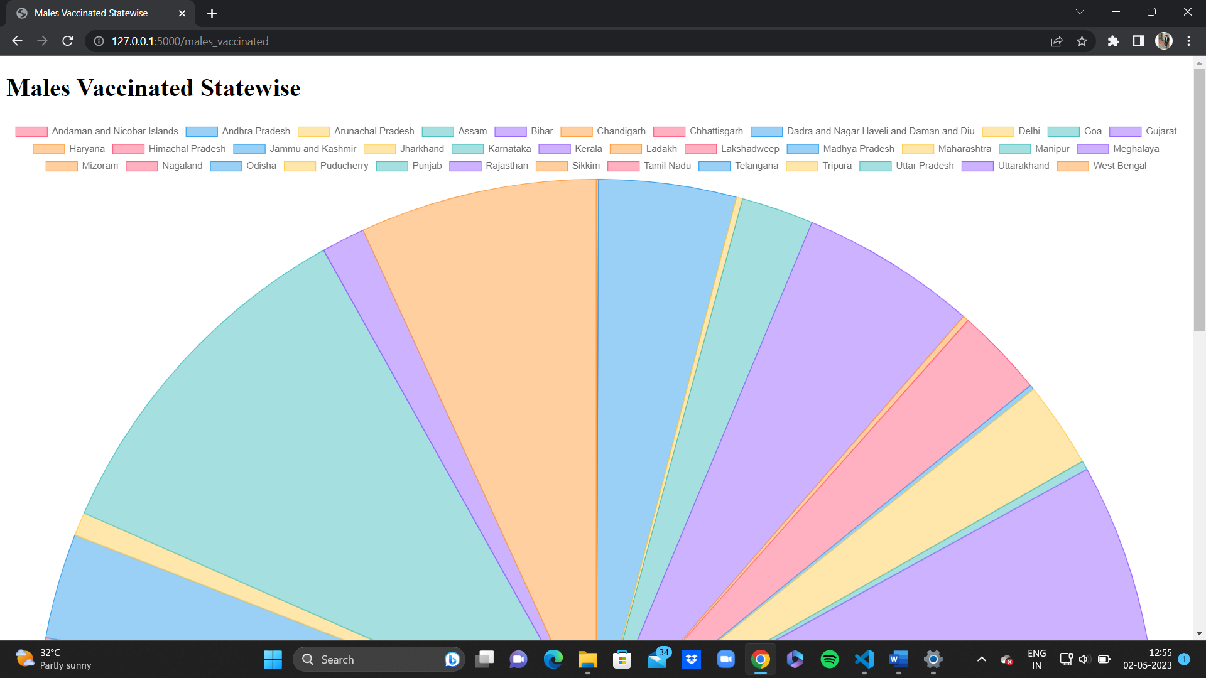

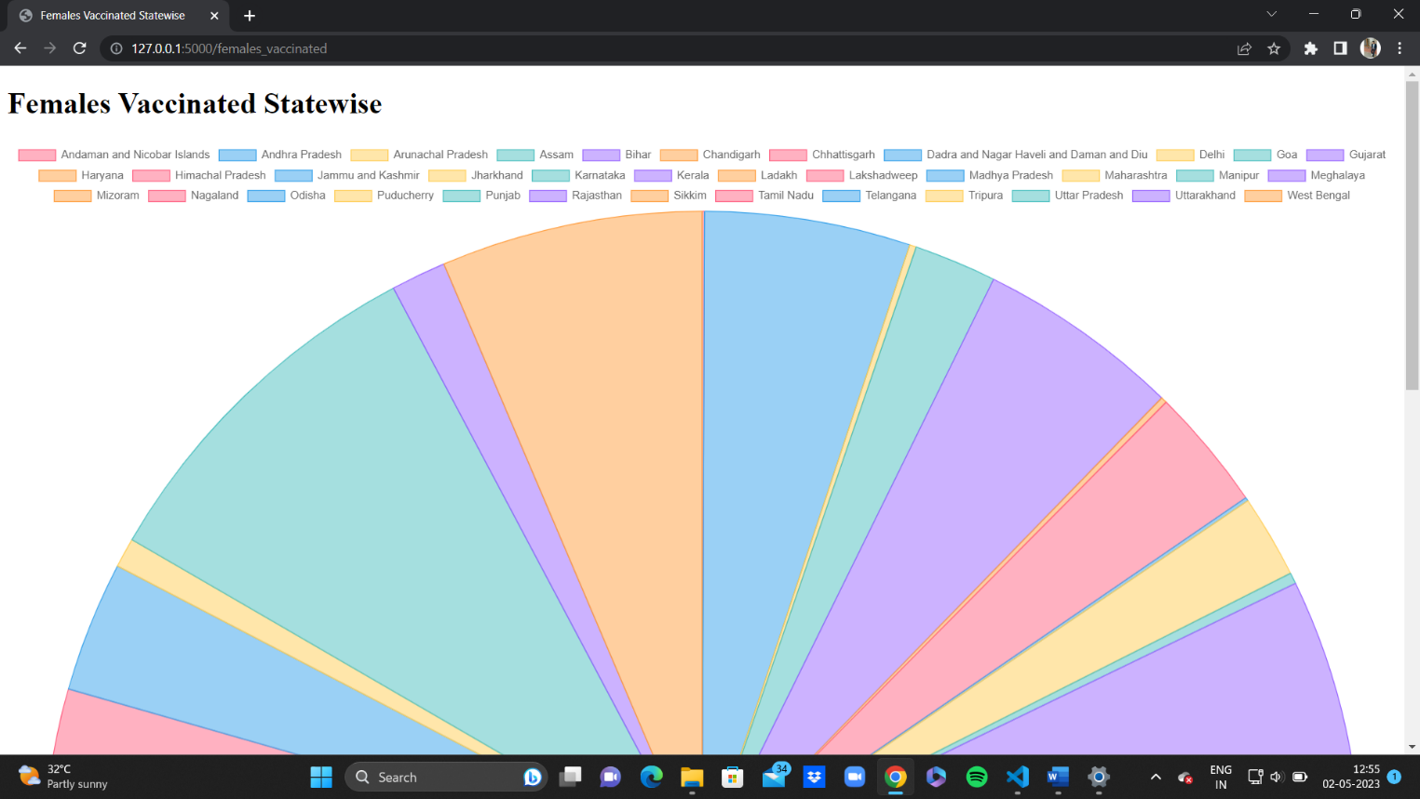

**Conclusion**

COVID-19 vaccination is a crucial strategy to combat the ongoing pandemic and its devastating impacts on health, economy, and society. However, the vaccination program faces many challenges, such as vaccine supply and distribution, vaccine hesitancy and misinformation, vaccine equity and access, and vaccine effectiveness and safety against emerging variants. This report has provided an overview of the current situation of COVID-19 vaccination in India and other countries, based on data from various sources. The report has also discussed the benefits and limitations of vaccination, as well as the recommendations for improving the vaccination program and achieving the desired outcomes. The report concludes that COVID-19 vaccination is a necessary but not sufficient condition for ending the pandemic. It requires a comprehensive and coordinated approach that involves multiple stakeholders, sectors, and interventions. It also requires continuous monitoring, evaluation, and adaptation to the changing dynamics of the pandemic. COVID-19 vaccination is not only a matter of public health, but also a matter of social justice and global solidarity.

# References

https://www.kaggle.com

https://www.google.com